DPN2 — DPN2 Task 2: Cloud Data Solution Implementation

Name: Taylor Wilkerson
Student ID: 011041148
Date: 4/5/2026

A. Using the instructions provided in the WGU GCP Database Playground, do the following:
1. Create the required schema objects within the appropriate Google Cloud Platform database, including tables, collections, documents, or index structures as appropriate that incorporate all the attributes from the dataset. Submit a screenshot of your schema as it appears in the GCP database.
a. Submit documentation of any code you used to create the database schema in part A1, identifying the components of the code and how they function.

A1a. Documentation of Code Used to Create the Database Schema
The database schema was created in Google BigQuery within the assigned WGU Google Cloud Platform dataset. Alliah Company requires a scalable cloud-based solution capable of supporting real-time transaction processing and analytics (Western Governors University, n.d.). A table named transactions was created to store the transaction dataset attributes in a structured relational format. The schema includes transaction-level fields, customer-related fields, and product-related shopping cart fields.
The schema was defined using SQL Data Definition Language (DDL). Each field was assigned a data type appropriate to the type of data being stored. For example, STRING was used for text-based attributes such as transaction identifiers, customer names, and product categories; DATE was used for the transaction date; FLOAT64 was used for numeric monetary values such as total_amount and price; and INT64 was used for the quantity field.
Because the original dataset included nested JSON-style structures for customer information and shopping cart data, those fields were flattened into individual relational columns in BigQuery. This design supports easier querying, filtering, reporting, and downstream analysis in a SQL-based cloud database environment.

SQL Code:
CREATE OR REPLACE TABLE `cal-2904-252b4aaa5753.wgu_d607_2c42895eccf52c7d.transactions` (
transaction_id STRING,
transaction_date DATE,
shipping_method STRING,
total_amount FLOAT64,
customer_id STRING,
customer_name STRING,
customer_email STRING,
customer_phone STRING,
customer_address STRING,
product_id STRING,
vendor STRING,
product_category STRING,
product_name STRING,
quantity INT64,
price FLOAT64
);

Code Component Explanation
CREATE OR REPLACE TABLE: Creates the transactions table in the specified BigQuery dataset. If the table already exists, it replaces it.
Project and Dataset Path:
cal-2904-252b4aaa5753.wgu_d607_2c42895eccf52c7d.transactions identifies the exact BigQuery location where the table is stored.
Field Definitions:
Each line defines a column name and its data type.
STRING: Used for text values such as customer names and shipping method.
DATE: Used to store the transaction date in date format.
FLOAT64: Used for decimal-based monetary values such as total purchase amount and product price.
INT64: Used for whole-number values such as quantity purchased.
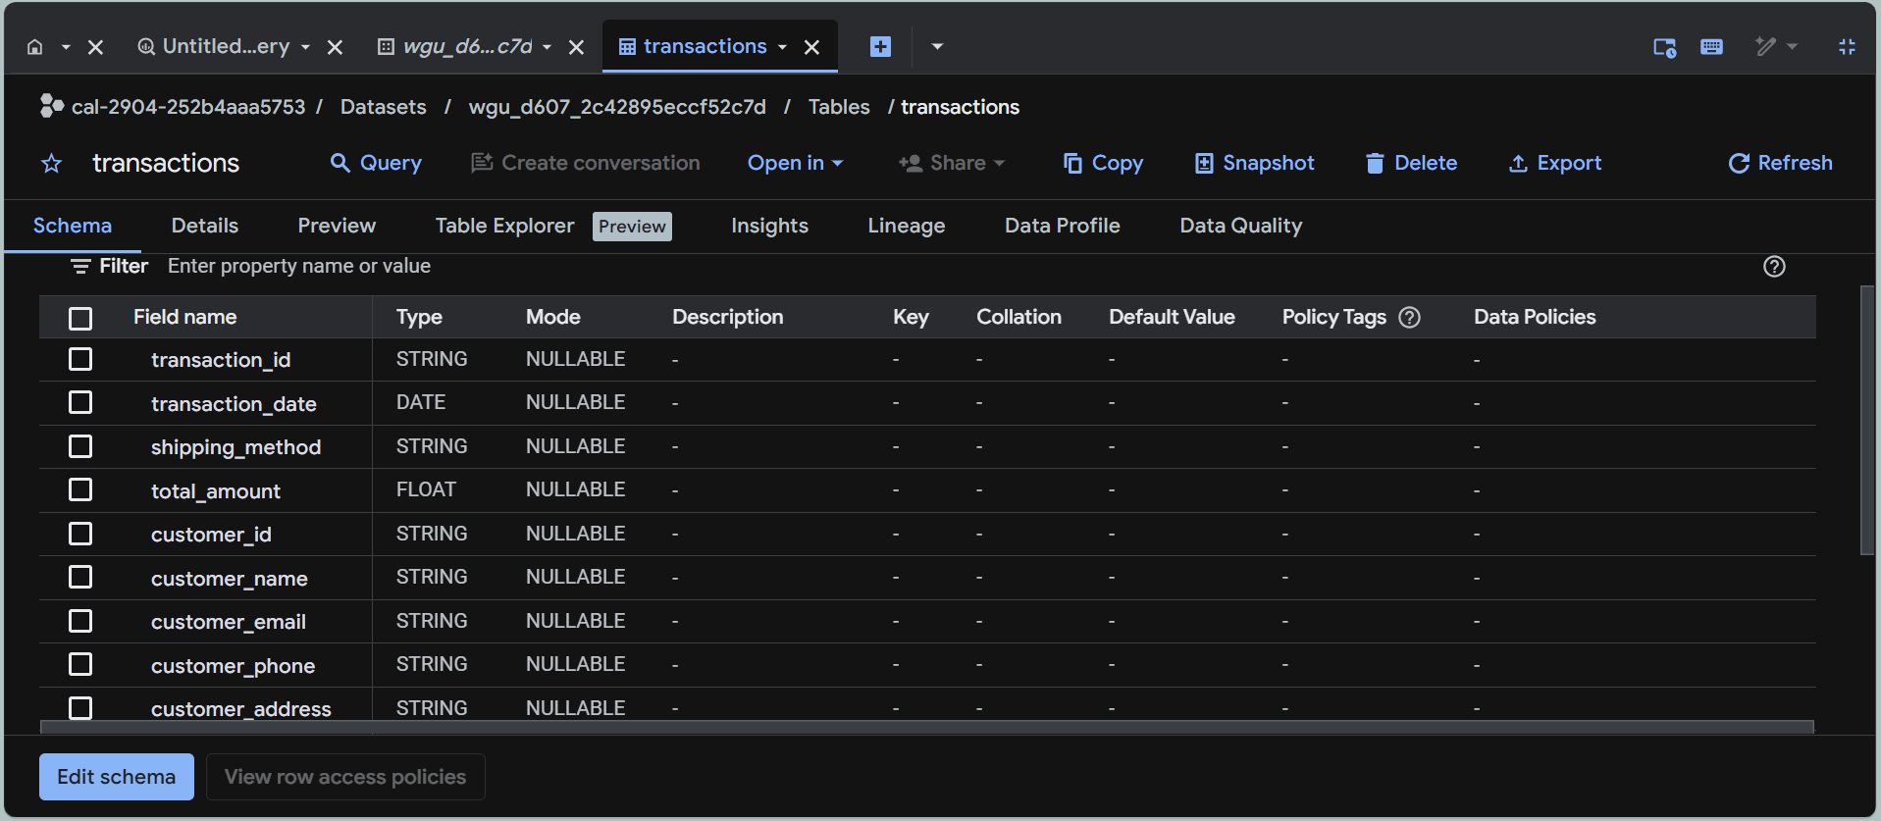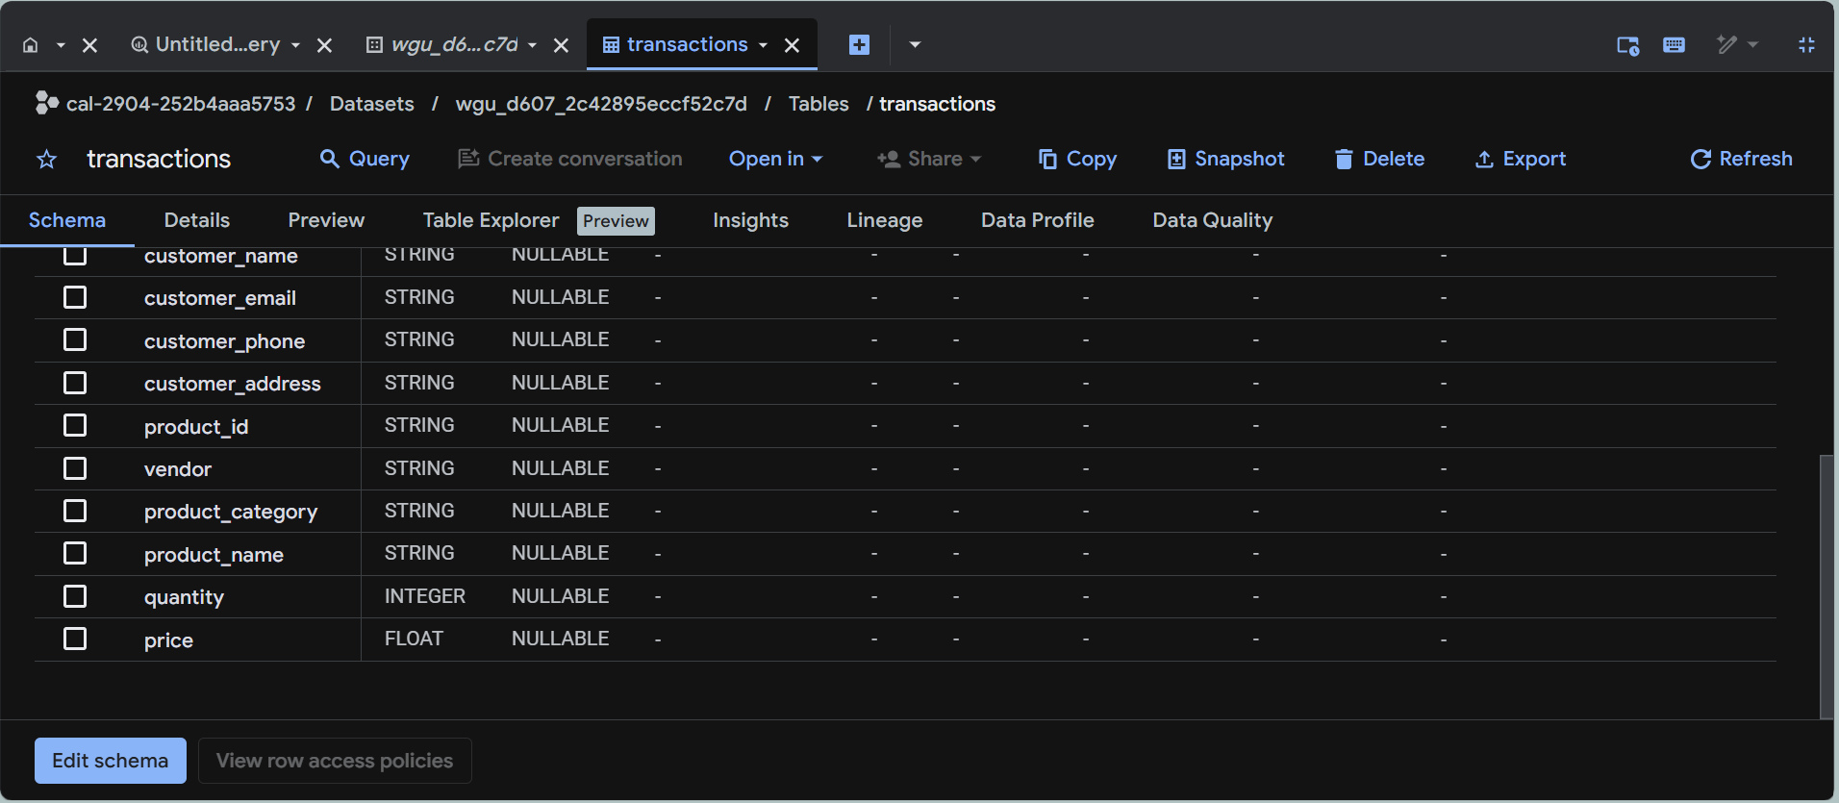

B. Using the instructions provided in the WGU GCP Database Playground, populate your database within the Database Playground by doing the following:
1. Insert at least 10 complete transaction records from the sample transaction dataset into your database. Submit a screenshot from the GCP database showing the inserted records.
*Included all scripts and uploaded into WGU portal for evaluation
Note: This can be accomplished manually or by using scripting and programming approaches.
To populate the database, transaction records from the provided sample transaction dataset were inserted into the transactions table in Google BigQuery. Because the original dataset included nested customer and shopping cart JSON structures, the records were inserted into the flattened relational schema created in part A. A minimum of 10 complete transaction records were loaded into the table, with each shopping cart item represented as an individual row tied back to its transaction and customer information. Multiple screenshots of the populated BigQuery table show the inserted records as provided as evidence of successful data insertion.

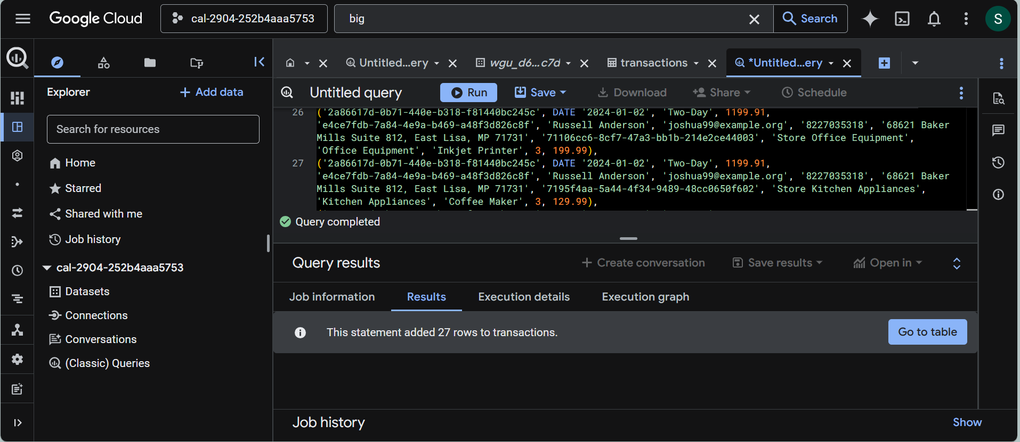
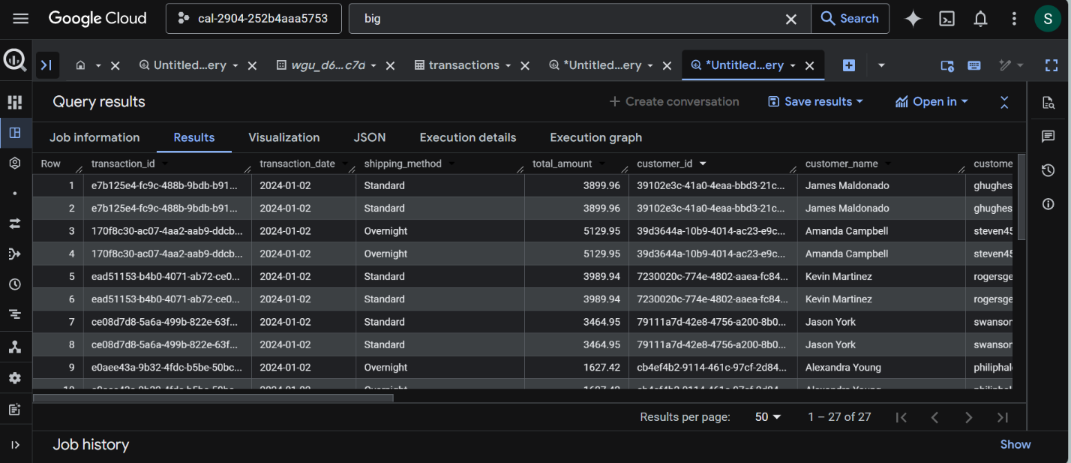
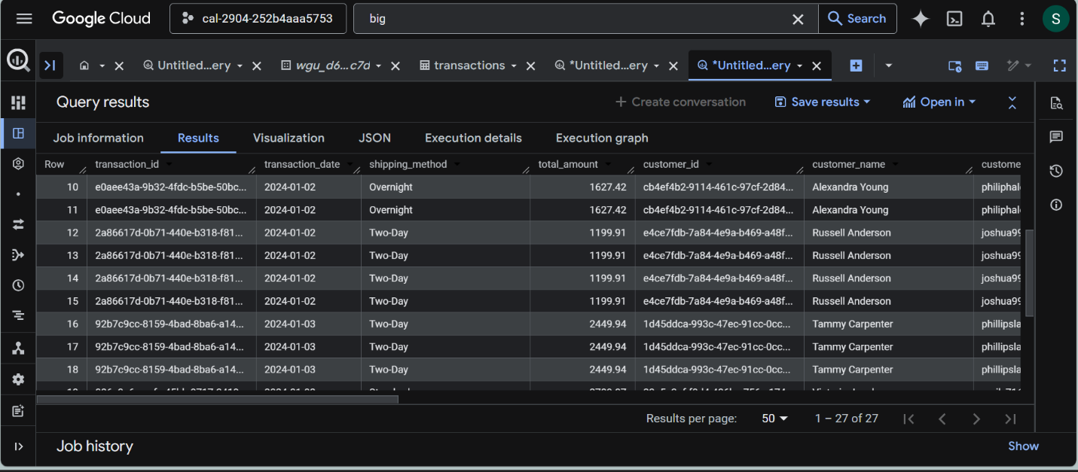
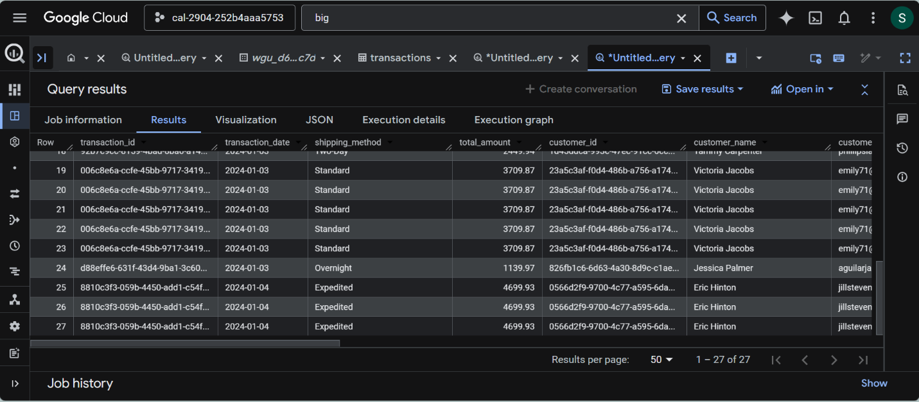
2. Explain the components of the code used in part B1 and how they function. Submit documentation of the code used to insert your records.
The records were inserted into the BigQuery transactions table using an INSERT INTO ... VALUES SQL statement. The INSERT INTO clause identifies the destination table and lists the target columns in the same order that the values are provided. Each parenthesized row in the VALUES section represents one inserted record. Because the original sample transaction dataset stores purchased items in a one-to-many shopping_cart JSON container, each product item was inserted as its own row while repeating the related transaction-level and customer-level fields. This approach preserves complete transaction information within the flattened relational schema created in part A. The DATE function was used to convert purchase dates into BigQuery’s date format, while text attributes were stored as STRING, money values as numeric fields, and quantities as integers. The inserted data came directly from the sample JSON transaction dataset and matches the attributes defined in the transaction data dictionary

References
DPN2 — DPN2 Task 2: Cloud Data Solution Implementation
https://tasks.wgu.edu/student/011041148/course/41540019/task/5487/overview
Western Governors University. (n.d.). Alliah Company scenario. Western Governors University.

